Team Charlie

Members: Elijah Wilkinson, Sean Christman, Gabriel Pedraza Torres, Dan Maher

Module: 10.1, Milestone # 2, Case Study: Outland Adventures

02/19/2023

**ERD**

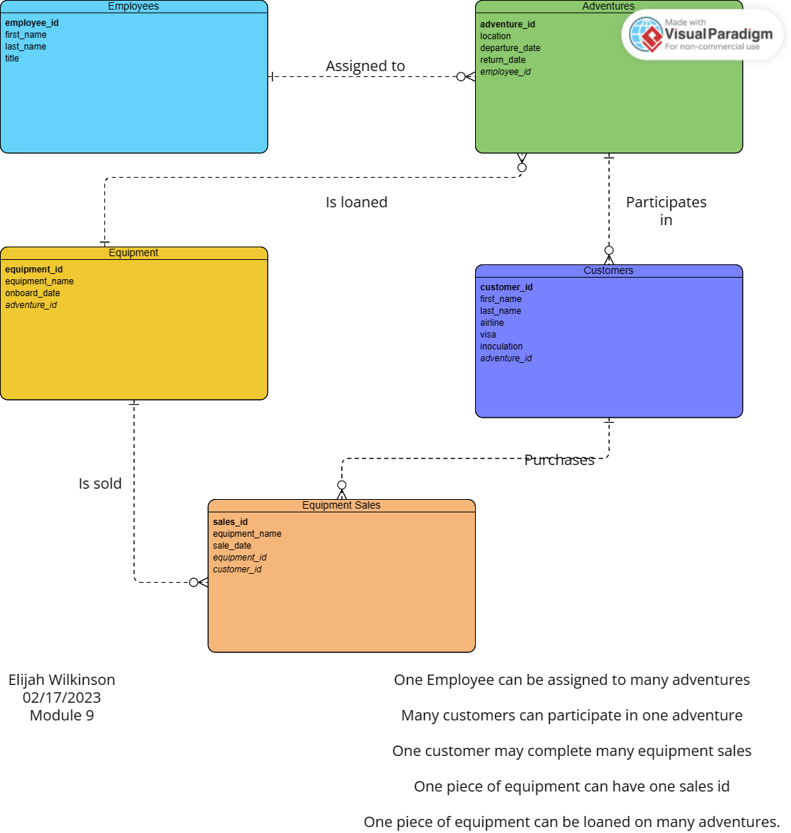

**Screenshot of Tables**

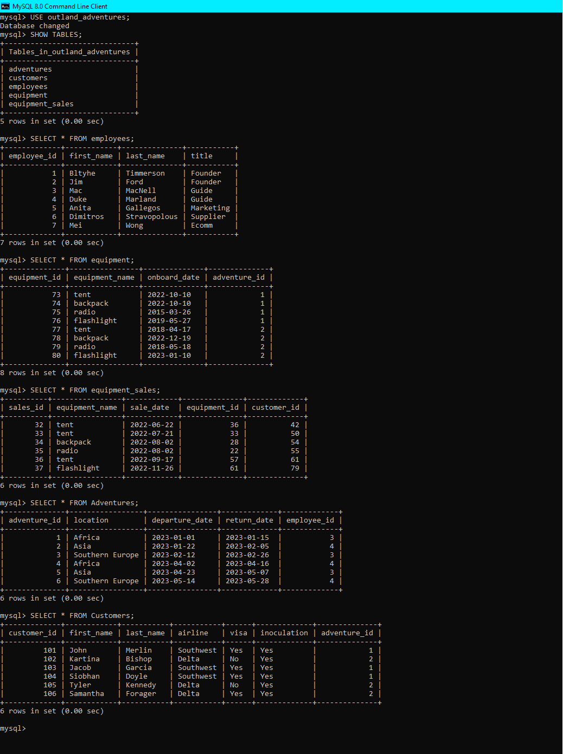

We ran into issues with our .py Script and it wouldn’t run as expected. To illustrate the tables with data included, I built the database and tables out in MySQL Command Line so that we could still have a visual representation of the tables in our database, even if it wasn’t from the .py script.

My database was built with commands such as

CREATE DATABASE outland_adventures;

CREATE TABLE employees (columns);

CREATE TABLE equipment (columns);

CREATE TABLE equipment_sales (columns);

CREATE TABLE adventures (columns);

CREATE TABLE customers (columns);

I then did...

INSERT INTO employees / equipment / equipment_sales / adventures / customers(columns) VALUES (individual record values for each table);

Then I selected all from each table to illustrate those results. We did something similar in our .py script, however, we couldn’t get it running as intended.